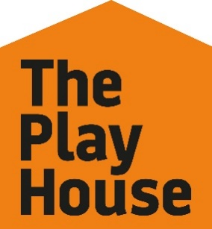 Equal Opportunity Monitoring Form

The Play House is committed to ensuring equal opportunities as an employer and we want to attract applications and work with staff from the most diverse pool of applicants. The information that you give us on this form will be treated confidentially and stored on our Human Resources database in an anonymised form. The form itself will not be retained and will be destroyed. The information will be used only to help us monitor the diversity of the applications we receive/staff we engage and to enable us to continue to develop our policies and procedures regarding equal opportunity issues. The personal information you supply below will NOT be made available to anyone in any form other than anonymised unless we expressly ask your permission.

This form is not used as a part of the recruitment and selection process, and is removed from the submitted application upon receipt and used for statistical purposes only.

Please tick as appropriate:

1. Gender Please choose the description you feel best defines the gender you identify as:

Female ☐ Male ☐ Non-Binary ☐ Prefer not to disclose ☐

Is your gender identity the same as the sex you were assigned at birth?

Yes ☐ No ☐ Prefer not to disclose ☐

2. Age
0-19 ☐ 20-24 ☐ 25-29 ☐ 30-34 ☐
35-39 ☐ 40-44 ☐ 45-49 ☐ 50-54 ☐
55-59 ☐ 60-64 ☐ 65+ ☐ Prefer not to disclose ☐

3. Sexual Orientation

The following descriptions are based on those recommended by Stonewall. Please choose the words that best suit you to describe your sexual orientation.

Bi☐ Gay Man ☐ Gay Woman/Lesbian☐ Heterosexual/Straight ☐
Prefer not to disclose ☐ Prefer to self-describe ☐

4. Ethnic Background

The following descriptions are based on those recommended by the Commission for Racial Equality. Please choose the words that best suit you to describe your ethnic background.

Black East Asian
British ☐ British ☐
African ☐ Chinese ☐
Caribbean ☐

Other (please say which) Other (please say which)

South Asian White
British ☐ British ☐
Bangladeshi ☐ Irish ☐
Pakistani ☐ English ☐
Indian ☐ Northern Irish ☐
Scottish ☐ Gypsy/Irish Traveller ☐
Welsh ☐

Other (please say which) Other (please say which)

Mixed Heritage
Please say which:

Other
Please describe: Prefer not to disclose ☐

If you have any other comments regarding your ethnic origin, please write them here:

4. Disability

The Disability Discrimination Act defines disability as a physical or mental impairment which has a substantial and long-term adverse effect on a person’s ability to carry out normal day-to-day activities.

Do you identify as a D/deaf or disabled person, or have a long-term health condition?

Yes ☐ No ☐ Prefer not to disclose ☐

