THE LAST TRAIN
A participatory theatre-in-education programme for ages 8–13
from The Play House, Birmingham

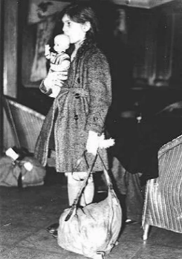
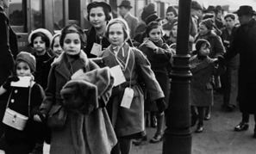
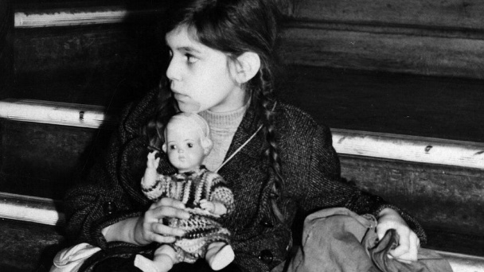
[
Birmingham, 1939. A ten-year-old girl arrives alone, carrying one suitcase. Inside it: some clothes, a pillowcase her mother embroidered, and a candle — packed in case the new country has no electricity.
The story
Inge Gershon is ten years old. She lives in Berlin with her mother, her father and Fritzi the dog — until the night the synagogue is burning, the glass is breaking on every street, and the soldiers are at the door. Slowly, then all at once, her world closes in. The dog is taken away because Jewish families may not keep pets. Her best friend Heinrich is forbidden from playing with her. Her teacher humiliates her in front of the class.
A scheme called Kindertransport — children’s transport — offers a way out. Inge’s parents decide that she must go. They will stay behind.
She arrives alone in Birmingham, carrying everything she owns in one suitcase. Mr and Mrs Coles take her in — well-meaning, but unprepared for the weight of what she carries. They lock her suitcase away. They rename her Helen.
Letters arrive from home, and are quietly kept from her. The Last Train follows Inge as she finds her way through fear, kindness, misunderstanding, and the slow, stubborn business of holding on to who she is.
A parallel from the present
Alongside Inge’s story, the piece glances briefly toward the present — a young person arriving alone in the same city today. No equivalence is drawn between these journeys; the parallels are allowed to do their own quiet work.
How it works
This is theatre that does not happen to children, but with them. A single class works with two professional actors for around half a day. Together, the pupils pack a suitcase with “one special thing”; they become children on the Kindertransport; they advise Inge’s father on how to break the difficult news; they sit on the train as Nazi guards board it; they speak to Mr Coles in role and challenge him for what he has done. The piece carries them carefully into difficult moral territory — about strangers, about home, about who belongs and who decides.

WHAT THE CHILDREN SAID
Voices from the original tour of The Last Train in 2009
In its first tour, The Last Train worked with more than 1,500 children across 30 Birmingham primary schools. The lines below are their own words — spoken in role as Inge, or in reflection after the drama.
“You have locked away my mother’s love in that case.”
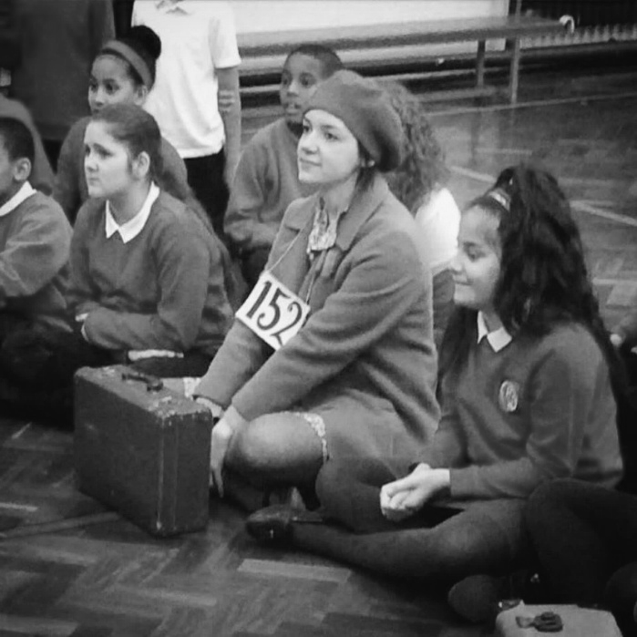
Year 6 pupil, in role as Inge, St James C of E Primary
“They are like toys, being put here and there, they have no control.”
Year 6 pupil, on Inge and the contemporary refugee, Yew Tree Community School

“Yes, but children have different feelings to adults and a longer future.”
Year 5 pupil, answering Mr Coles, St Mary’s C of E Primary
“I’d rather be upset than dead.”
Year 6 pupil, when asked whether Inge’s parents were right to send her, Blandford Mere Primary

Belonging — a follow-up strand
A follow-up strand, Belonging, takes the work further into the life of the school. Designed to sit alongside a school’s pastoral strategy, it offers structured material for teachers to extend the conversation: belonging in the classroom, in the city, and across difference.

About The Play House
The Play House has been making participatory theatre with Birmingham primary schools since 1986. The company delivers more than a thousand sessions each year across the city and the West Midlands, working with a single class at a time so that every pupil can take an active part.
The Last Train was first devised in 2009, drawing on interviews with Kindertransport survivors at the Holocaust Centre, Laxton — including the testimony of Hermann Hirschberger, who travelled to Britain as a child. It toured to 30 schools and over 1,500 children in that first season. It is being newly reworked for the company’s 40th anniversary year, as a permanent addition to our repertoire.
The Play House (Birmingham) Ltd. Registered charity 1034809. Company 02828276
